Skill 09 Lab - Configuring EIGRP Dynamic Routing
Coffee House ↔ Fallout | CCNA Packet Tracer Student Guide
Replace LAN-to-LAN static routes with EIGRP autonomous system 1
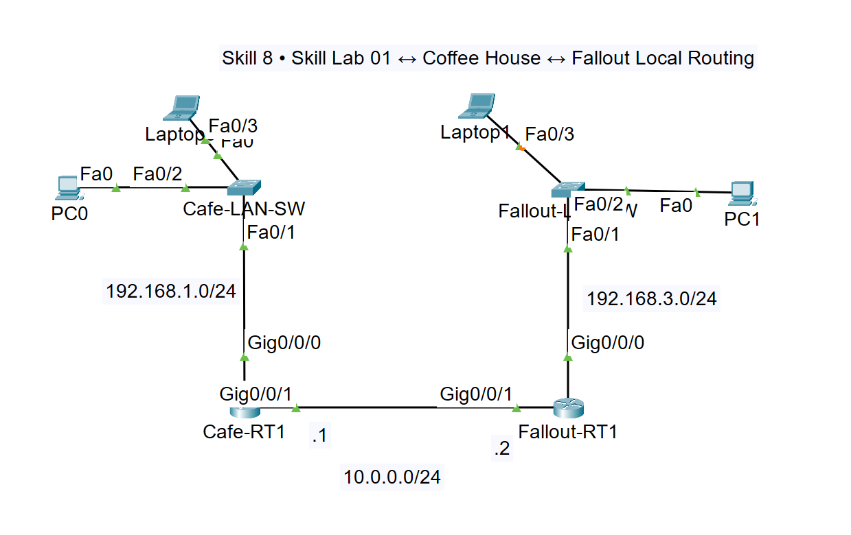
Figure 1. Updated Coffee House and Fallout topology used for this lab.
Addressing note: The diagram labels the inter-router network as 10.0.0.0/24. This guide therefore uses 10.0.0.1/24 and 10.0.0.2/24. PC0 is 192.168.1.51/24 and PC1 is 192.168.3.101/24.

1. Deployment objectives
- Remove only the existing LAN-to-LAN static routes; retain any default routes.
- Enable classic EIGRP autonomous system 1 on Cafe-RT1 and Fallout-RT1.
- Advertise each local LAN and the shared 10.0.0.0/24 router link.
- Form an EIGRP neighbor adjacency and learn the remote LAN as an EIGRP D route.
- Validate end-to-end connectivity, traceroute behavior, ARP learning, and saved configurations.

2. Network design and addressing plan
Device | Interface | Address / Mask | Gateway / Role
PC0 | Fa0 | 192.168.1.51/24 | GW 192.168.1.1
Laptop0 | Fa0 | Suggested: 192.168.1.52/24 | GW 192.168.1.1
Cafe-LAN-SW | VLAN 1 (optional) | 192.168.1.2/24 | GW 192.168.1.1
Cafe-RT1 | G0/0/0 | 192.168.1.1/24 | Coffee House LAN
Cafe-RT1 | G0/0/1 | 10.0.0.1/24 | EIGRP neighbor link
Fallout-RT1 | G0/0/1 | 10.0.0.2/24 | EIGRP neighbor link
Fallout-RT1 | G0/0/0 | 192.168.3.1/24 | Fallout LAN
Fallout-LAN-SW | VLAN 1 (optional) | 192.168.3.2/24 | GW 192.168.3.1
PC1 | Fa0 | 192.168.3.101/24 | GW 192.168.3.1
Laptop1 | Fa0 | Suggested: 192.168.3.102/24 | GW 192.168.3.1

3. Place and cable the devices
- Place two ISR 4321 routers, two 2960 switches, PC0, PC1, and two laptops in the Logical workspace.
- Rename the devices Cafe-RT1, Fallout-RT1, Cafe-LAN-SW, Fallout-LAN-SW, PC0, PC1, Laptop0, and Laptop1.
- Use copper straight-through (or Automatic Connection) for end-device-to-switch and switch-to-router links.
- Connect Cafe-RT1 G0/0/1 directly to Fallout-RT1 G0/0/1. Packet Tracer Automatic Connection is acceptable.
- Wait for green link indicators. Router interfaces require the no shutdown command.
From | Port | To | Port
PC0 | Fa0 | Cafe-LAN-SW | Fa0/2
Laptop0 | Fa0 | Cafe-LAN-SW | Fa0/3
Cafe-LAN-SW | Fa0/1 | Cafe-RT1 | G0/0/0
Cafe-RT1 | G0/0/1 | Fallout-RT1 | G0/0/1
Fallout-RT1 | G0/0/0 | Fallout-LAN-SW | Fa0/1
Fallout-LAN-SW | Fa0/2 | PC1 | Fa0
Fallout-LAN-SW | Fa0/3 | Laptop1 | Fa0

4. Configure endpoints and Layer 2 switches

PC0 and PC1
Packet Tracer PC-PT devices use Desktop > IP Configuration. Enter:
Host | IP address | Subnet mask | Default gateway
PC0 | 192.168.1.51 | 255.255.255.0 | 192.168.1.1
PC1 | 192.168.3.101 | 255.255.255.0 | 192.168.3.1

Verify from each PC command prompt:
ipconfig

Cafe-LAN-SW
enable
configure terminal
hostname Cafe-LAN-SW
no ip domain-lookup
interface fastethernet0/1
description Uplink to Cafe-RT1 G0/0/0
switchport mode access
no shutdown
exit
interface fastethernet0/2
description PC0 - 192.168.1.51
switchport mode access
spanning-tree portfast
no shutdown
exit
interface fastethernet0/3
description Laptop0
switchport mode access
spanning-tree portfast
no shutdown
exit
interface vlan 1
ip address 192.168.1.2 255.255.255.0
no shutdown
exit
ip default-gateway 192.168.1.1
end
copy running-config startup-config

Fallout-LAN-SW
enable
configure terminal
hostname Fallout-LAN-SW
no ip domain-lookup
interface fastethernet0/1
description Uplink to Fallout-RT1 G0/0/0
switchport mode access
no shutdown
exit
interface fastethernet0/2
description PC1 - 192.168.3.101
switchport mode access
spanning-tree portfast
no shutdown
exit
interface fastethernet0/3
description Laptop1
switchport mode access
spanning-tree portfast
no shutdown
exit
interface vlan 1
ip address 192.168.3.2 255.255.255.0
no shutdown
exit
ip default-gateway 192.168.3.1
end
copy running-config startup-config

5. Configure router interfaces

Cafe-RT1 interface configuration
enable
configure terminal
hostname Cafe-RT1
no ip domain-lookup
interface gigabitethernet0/0/0
description Coffee House LAN to Cafe-LAN-SW
ip address 192.168.1.1 255.255.255.0
no shutdown
exit
interface gigabitethernet0/0/1
description EIGRP neighbor link to Fallout-RT1
ip address 10.0.0.1 255.255.255.0
no shutdown
exit
end

Fallout-RT1 interface configuration
enable
configure terminal
hostname Fallout-RT1
no ip domain-lookup
interface gigabitethernet0/0/0
description Fallout LAN to Fallout-LAN-SW
ip address 192.168.3.1 255.255.255.0
no shutdown
exit
interface gigabitethernet0/0/1
description EIGRP neighbor link to Cafe-RT1
ip address 10.0.0.2 255.255.255.0
no shutdown
exit
end

6. Remove the LAN-to-LAN static routes
Important: Remove only the static route that points to the opposite private LAN. Do not remove any existing default route (0.0.0.0/0).

A. Identify the existing routes
Cafe-RT1# show running-config | include ^ip route
Cafe-RT1# show ip route static
Fallout-RT1# show running-config | include ^ip route
Fallout-RT1# show ip route static
Record the exact next hop before deleting each route. Expected LAN-to-LAN routes:
Router | Static route to remove
Cafe-RT1 | ip route 192.168.3.0 255.255.255.0 10.0.0.2
Fallout-RT1 | ip route 192.168.1.0 255.255.255.0 10.0.0.1

B. Remove the routes
Cafe-RT1# configure terminal
Cafe-RT1(config)# no ip route 192.168.3.0 255.255.255.0 10.0.0.2
Cafe-RT1(config)# end
Cafe-RT1# show ip route 192.168.3.0
Fallout-RT1# configure terminal
Fallout-RT1(config)# no ip route 192.168.1.0 255.255.255.0 10.0.0.1
Fallout-RT1(config)# end
Fallout-RT1# show ip route 192.168.1.0
Expected result: Before EIGRP is configured, the remote LAN route should be absent and end-to-end ping should fail. This proves the static route was truly removed.

7. Enable EIGRP on Cafe-RT1
The EIGRP network command identifies which directly connected networks participate in the EIGRP process. It does not create a route or assign an IP address. Instead, it enables EIGRP on interfaces whose IP addresses match the network and wildcard mask, and it advertises those connected networks to EIGRP neighbors. For example, network 192.168.1.0 0.0.0.255 matches the 192.168.1.0/24 LAN, while network 10.0.0.0 0.0.0.255 matches the router-to-router link.
Cafe-RT1# configure terminal
Cafe-RT1(config)# router eigrp 1
Cafe-RT1(config-router)# no auto-summary
Cafe-RT1(config-router)# network 192.168.1.0 0.0.0.255
Cafe-RT1(config-router)# network 10.0.0.0 0.0.0.255
Cafe-RT1(config-router)# passive-interface gigabitethernet0/0/0
Cafe-RT1(config-router)# end
Why passive-interface?: The Coffee House LAN is still advertised, but Cafe-RT1 will not send EIGRP hello packets toward PCs and the switch. The G0/0/1 neighbor link remains active.

Cafe-RT1# show ip protocols
Cafe-RT1# show ip eigrp interfaces
Cafe-RT1# show ip eigrp neighbors

8. Enable EIGRP on Fallout-RT1
Fallout-RT1# configure terminal
Fallout-RT1(config)# router eigrp 1
Fallout-RT1(config-router)# no auto-summary
Fallout-RT1(config-router)# network 192.168.3.0 0.0.0.255
Fallout-RT1(config-router)# network 10.0.0.0 0.0.0.255
Fallout-RT1(config-router)# passive-interface gigabitethernet0/0/0
Fallout-RT1(config-router)# end
Fallout-RT1# show ip protocols
Fallout-RT1# show ip eigrp interfaces
Fallout-RT1# show ip eigrp neighbors
ISP-facing exclusion: The diagram does not show an ISP interface. If your activity has one, do not add its network to EIGRP. Keep any default route in place and advertise only the two LANs and 10.0.0.0/24.

9. Validate EIGRP dynamic routing

A. Verify neighbor adjacency
Cafe-RT1# show ip eigrp neighbors
Fallout-RT1# show ip eigrp neighbors
Each router should list one neighbor on G0/0/1. Cafe-RT1 should see neighbor 10.0.0.2, and Fallout-RT1 should see neighbor 10.0.0.1.

B. Verify EIGRP-learned routes
Cafe-RT1# show ip route eigrp
Cafe-RT1# show ip route 192.168.3.0
Fallout-RT1# show ip route eigrp
Fallout-RT1# show ip route 192.168.1.0
Expected route code: The remote LAN should appear with code D. Example on Cafe-RT1: D 192.168.3.0/24 [90/...] via 10.0.0.2. Example on Fallout-RT1: D 192.168.1.0/24 [90/...] via 10.0.0.1.

C. Test links and end-to-end connectivity
Cafe-RT1# ping 10.0.0.2
Fallout-RT1# ping 10.0.0.1
PC0> ping 192.168.1.1
PC0> ping 192.168.3.101
PC1> ping 192.168.3.1
PC1> ping 192.168.1.51

D. Trace the path from PC0 to PC1
PC0> tracert 192.168.3.101
Hop | Expected address | Device
1 | 192.168.1.1 | Cafe-RT1 LAN interface
2 | 10.0.0.2 | Fallout-RT1 WAN interface
3 | 192.168.3.101 | PC1 destination

10. Inspect ARP, MAC, and EIGRP information

PC0
arp -a
tracert 192.168.3.101
PC0 should cache the MAC address of its default gateway (192.168.1.1), not the remote PC1 MAC address.

Switches
show mac address-table
show interfaces status
show ip interface brief

Routers
show arp
show ip route
show ip route eigrp
show ip eigrp neighbors
show ip eigrp topology
show ip protocols

11. Troubleshooting guide
Symptom | Likely cause | Corrective check
No EIGRP neighbor | AS mismatch, WAN interface down, wrong IP/mask, passive WAN | show ip eigrp neighbors; show ip interface brief; show run | section router eigrp
Neighbor forms but no remote route | Missing LAN network command or wrong wildcard | show ip protocols; verify 192.168.1.0/24 and 192.168.3.0/24 statements
Route is still S instead of D | Static route was not removed | show run | include ^ip route; remove only LAN-to-LAN static route
PC cannot reach local gateway | Wrong host IP/gateway, switch port down, router LAN interface down | ipconfig; show interfaces status; show ip interface brief
EIGRP route present but ping fails | Host firewall, wrong gateway, return path issue | Ping hop-by-hop; verify both PCs and both learned routes
First ping loses one packet | ARP resolution | Repeat ping after ARP tables populate

12. Save and complete the lab
Cafe-RT1# copy running-config startup-config
Fallout-RT1# copy running-config startup-config
Cafe-LAN-SW# copy running-config startup-config
Fallout-LAN-SW# copy running-config startup-config
☐ LAN-to-LAN static routes have been removed, while default routes remain.
☐ Both routers use EIGRP autonomous system 1.
☐ Cafe-RT1 advertises 192.168.1.0/24 and 10.0.0.0/24.
☐ Fallout-RT1 advertises 192.168.3.0/24 and 10.0.0.0/24.
☐ Each router lists the other as an EIGRP neighbor on G0/0/1.
☐ Cafe-RT1 has a D route to 192.168.3.0/24.
☐ Fallout-RT1 has a D route to 192.168.1.0/24.
☐ PC0 can ping and trace to PC1 at 192.168.3.101.
☐ All router and switch configurations are saved.

